Step 1: Connect the measurement equipment leads to the corresponding phase terminals of the motor assembly as shown in picture below.

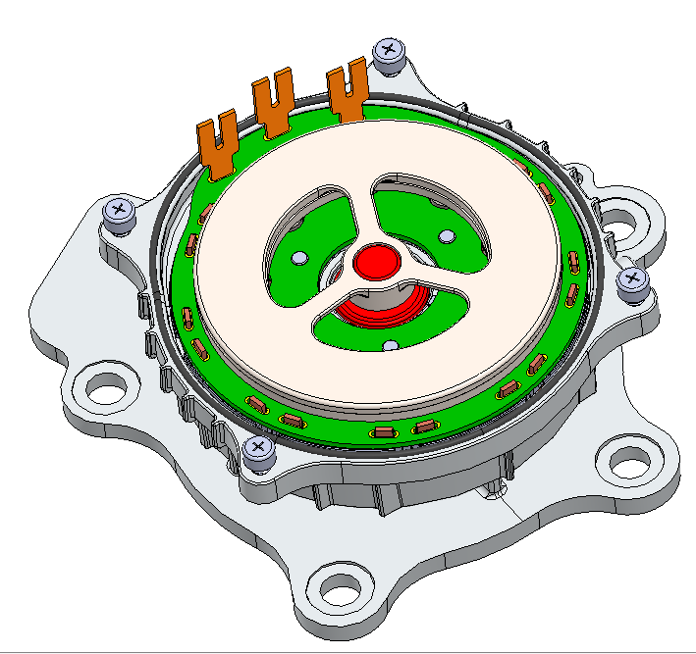

U

V

W

Step 2: Measure the following

1. Phase resistance

Phase resistance value should be within the range of ---------------

1. Phase Inductance

Phase inductance value should be within the range of ---------------

Step 3: Power the motor and control it to run from 300 RPM to 6000RPM and measure the following

1. RPM vs. Current

Current vs. RPM values should be within the range as shown in the following graph

1. Back EMF

Back emf vs. RPM values should be within the range as shown in the following graph

Step 4: Connect the tester connector to the pump as shown below.

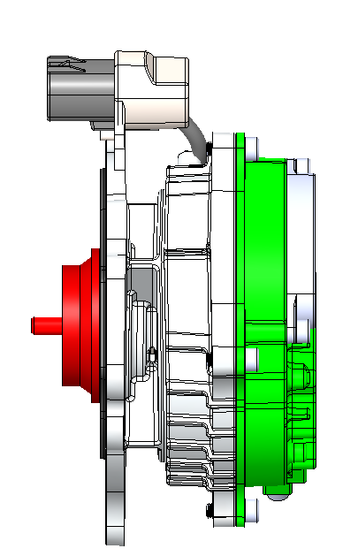

Connector

Step 5: Check the following parameters

1. Communication check: send signal & return signal

|  |  |  |
| --- | --- | --- |
| RPM | Sent signal | Return signal |
| 600 | tbd | tbd |
| 3500 | tbd | tbd |
| 4500 | tbd | tbd |
| 6000 | tbd | tbd |

1. PWM vs. RPM

|  |  |  |
| --- | --- | --- |
| RPM | Sent signal | Return signal |
| 600 | tbd | tbd |
| 3500 | tbd | tbd |
| 4500 | tbd | tbd |
| 6000 | tbd | tbd |

1. Voltage Check

Conduct above tests at high voltage (tbd)

Conduct above tests at low voltage (tbd)